SMART WASTE MANAGEMENT SYSTEM FOR METROPOLICATION CITIES

TEAM ID:PNT2022TMID26538

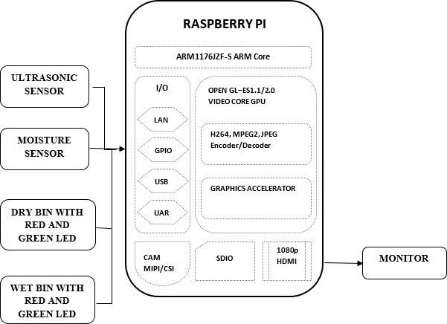

INSERT

GARBAGE

WASTE

DATA

TRANSMIT

GARBAGE

LEVEL

DATA

MONITORING

SYSTEM

ADMIN

OF

THAT

LOCATION

LEVEL

DATA

RUN

FILL

LEVEL

ALERT